nepal college of information technology
ut spring 2012

Level: Bachelor | Semester: IV | Year : 2012
Programme: BE |  | Full Marks: 60
Course: Engineering Mathematics IV |  | Pass Marks: 30
 |  | Time : 2hrs.

Candidates are required to give their answers in their own words as far as practicable.
The figures in the margin indicate full marks.

Attempt all the questions.

 | - State and proof necessary condition for analyticity of a function by using C-R equation.  - Define a harmonic function and its harmonic conjugate. Show that u(x, y) = sinx coshy is harmonic and find its harmonic Conjugate v(x, y) so that the function  f(x, y) = u(x, y) + iv(x, y) is analytic | 8  7
 | - State and prove Cauchy's integral formula and use it to find 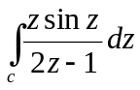where C is the unit circle counterclockwise  - Express the following function of Z in the form of u+iv  - Sin Z  - Cosh Z  - Show that the function  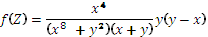  (hint: choose the path y=x⁴ and allow x->0 along this) | 8  7
 | - What is a Fourier Integral? Using Fourier integral, show that 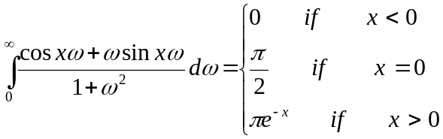  - Define fourier sine and cosine transform. Find the Fourier cosine transform of the function f(x) = e^{-ax} (a>0). | 8  7
 | - Show that where 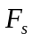 stands for the Fourier sine transform.  - Let f(x) be continuous on x-axis and f(x)->0 as |x|->∞ and f’(x) absolutely integrable on x-axis , then  F[f’(x)]=iw F[f(x)] and F[f’’(x)]= - w² F[f(x)] | 8
.b) Find fourier sine transform of e^{-x} and by using paraseval’s identity, show that
